# COMPUTER NETWORKS LAB 1

## **OBJECTIVES**

* To familiarize students with Cisco Packet Tracer.
* To set up a peer-to-peer (P2P) communication network.
* To study different types of network cables and their colour codes.
* To document the observations and save the configuration file in a GitHub repository.

## **STEPS TAKEN TO SET UP THE NETWORK**

STEP 1: Dragged the end devices and a Switch-PT on to the canvas.

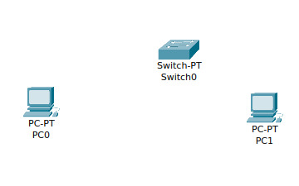

STEP 2: connected the end devices to the switch using Straight-through copper cables.

FastEthernet0 on PC0 to FastEthernet0/1 on Switch-PT

Fs/0 on PC1 to Fs0/2 on Switch-PT

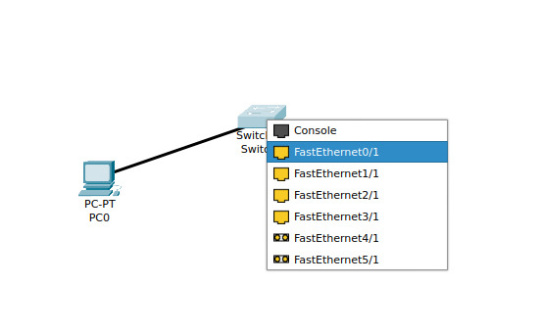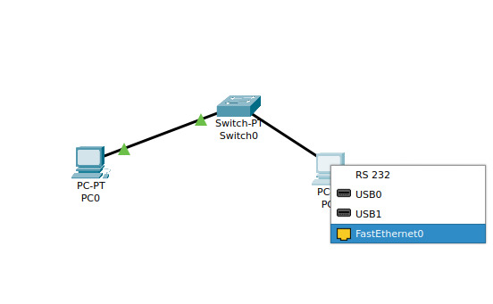

STEP 3: Started configuring the IP address and subnet mask for each end device in the network.

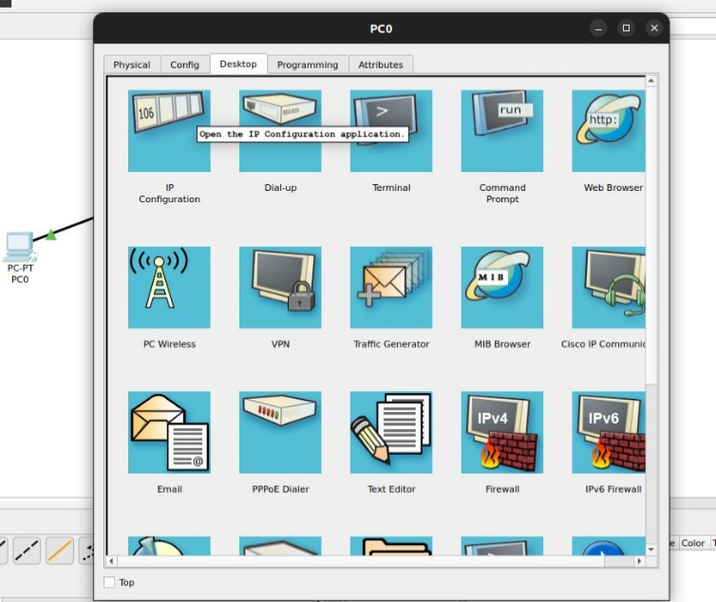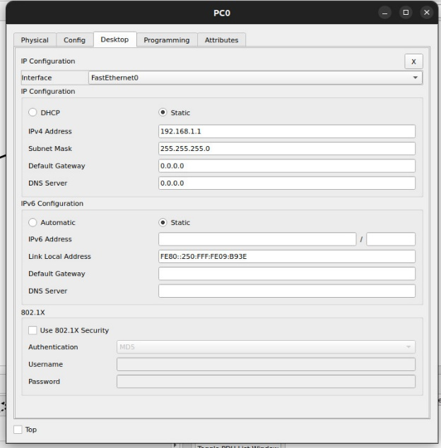

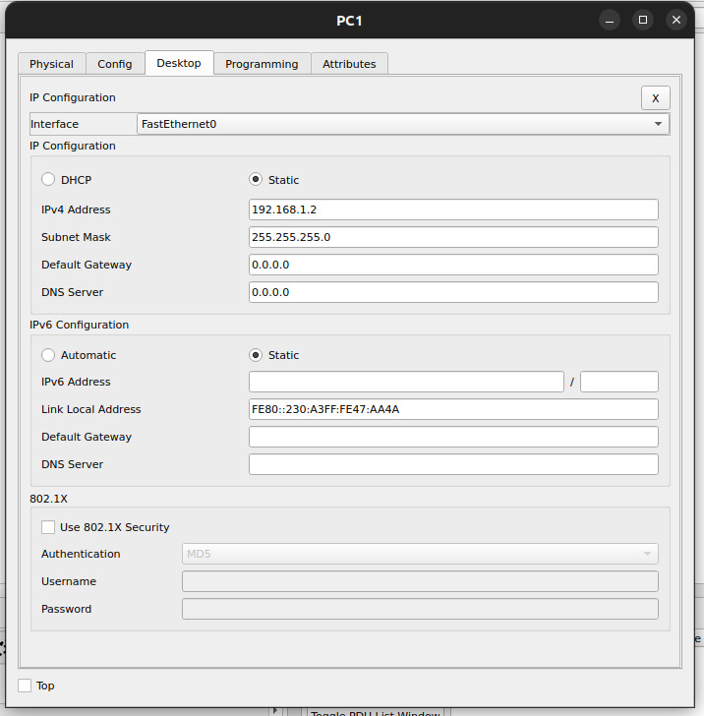

STEP 4: Using the ping command

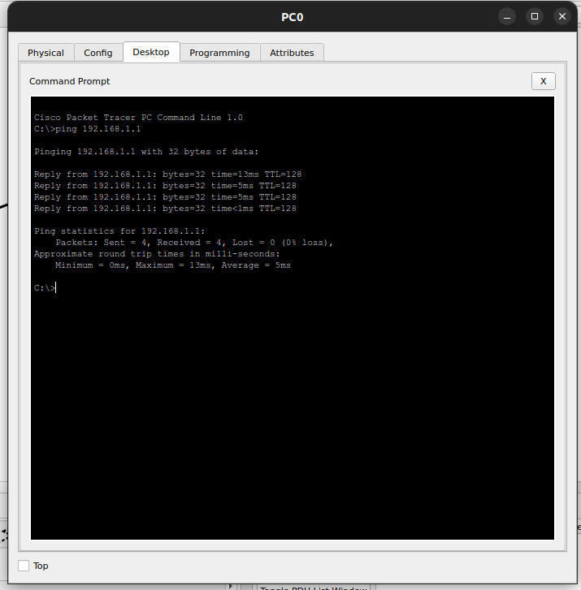

## **Observations using simulation mode:**

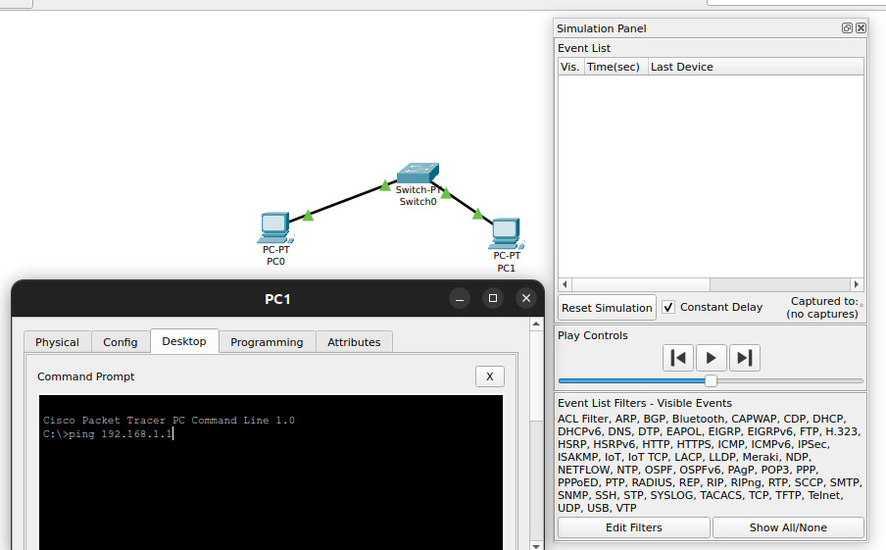

I pinged PC0 from PC1.

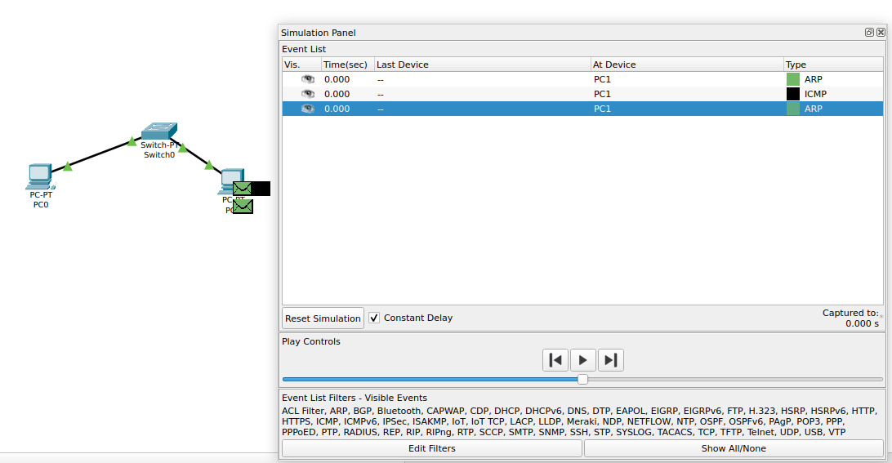

An ICMP packet and an ARP packet were generated. The ARP packet seems to be an ARP request.

The destination MAC of this ARP packet is a broadcast MAC FFFF.FFFF.FFFF

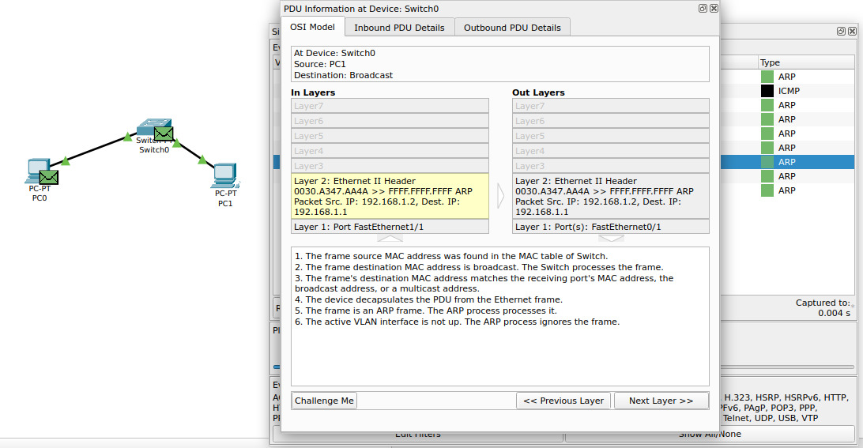

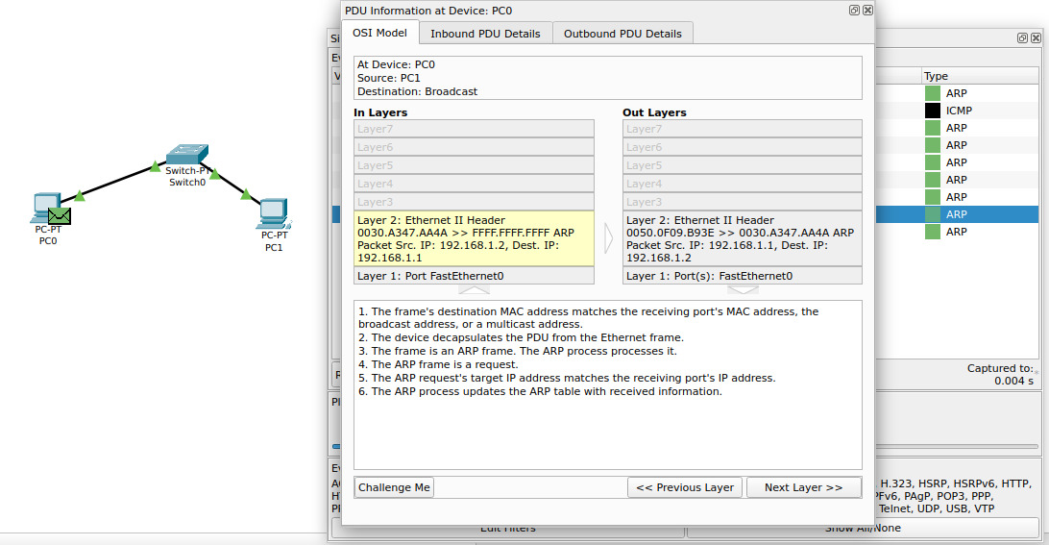

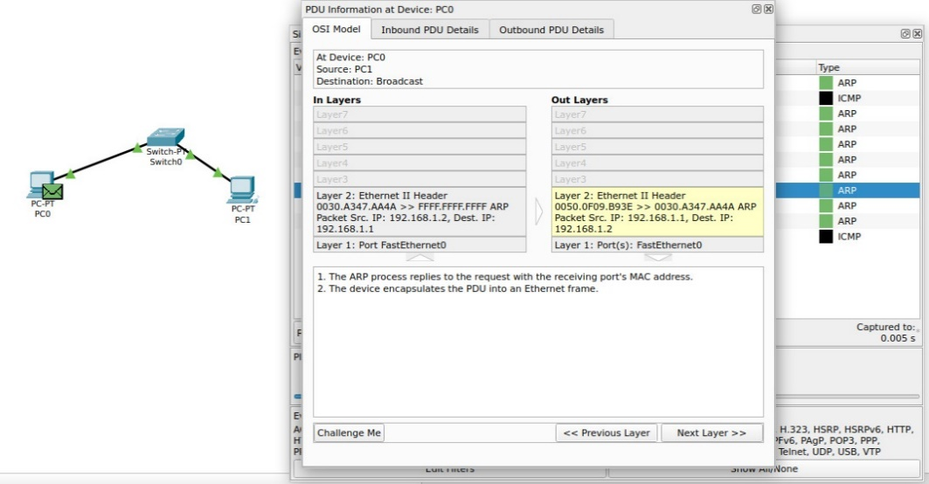

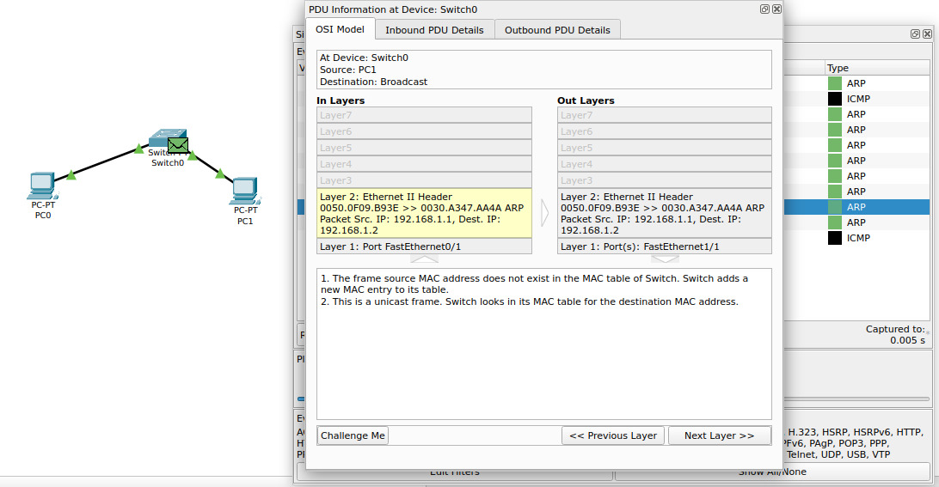

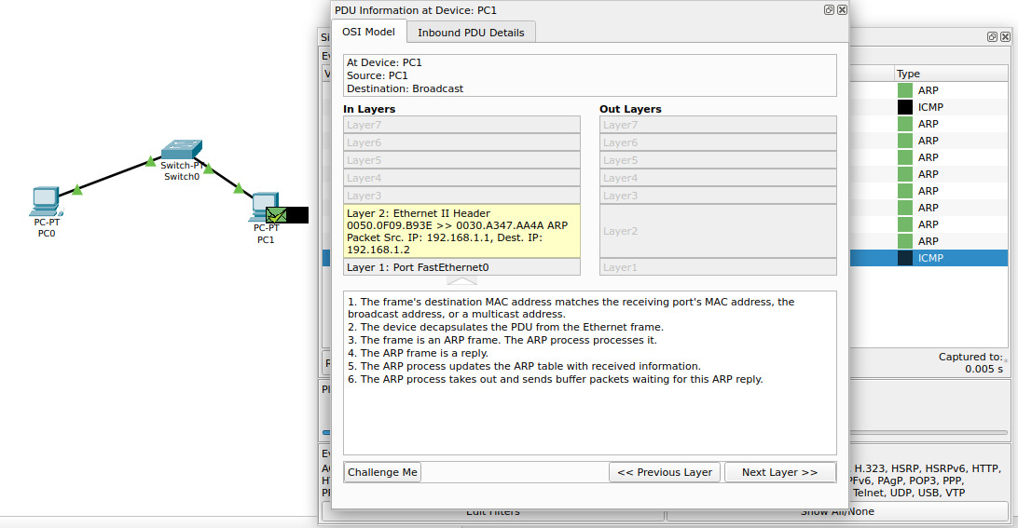

ICMP:  


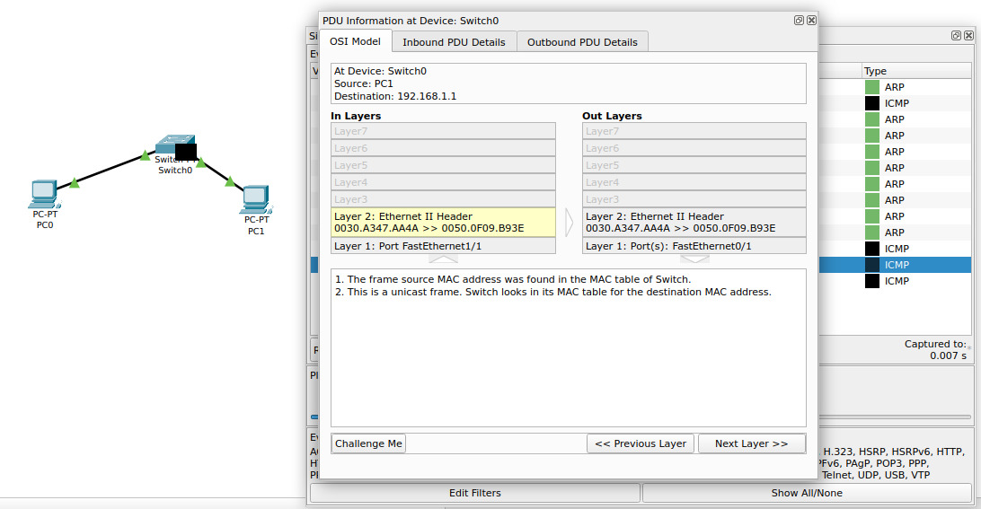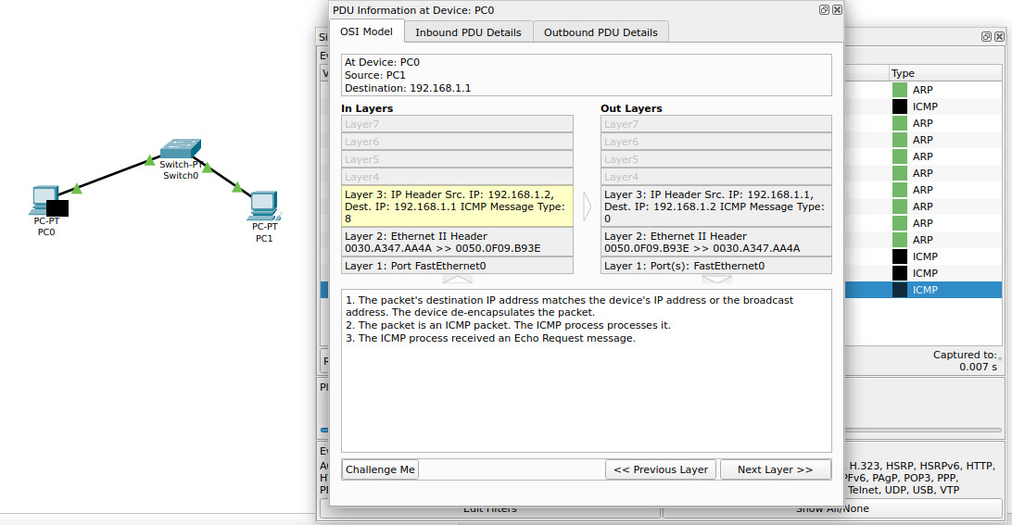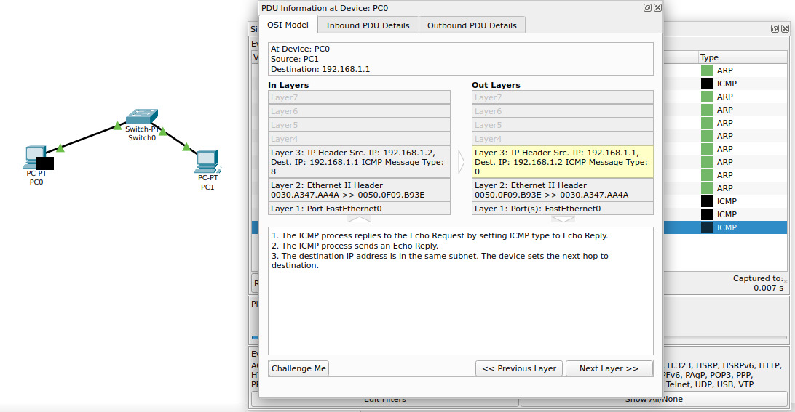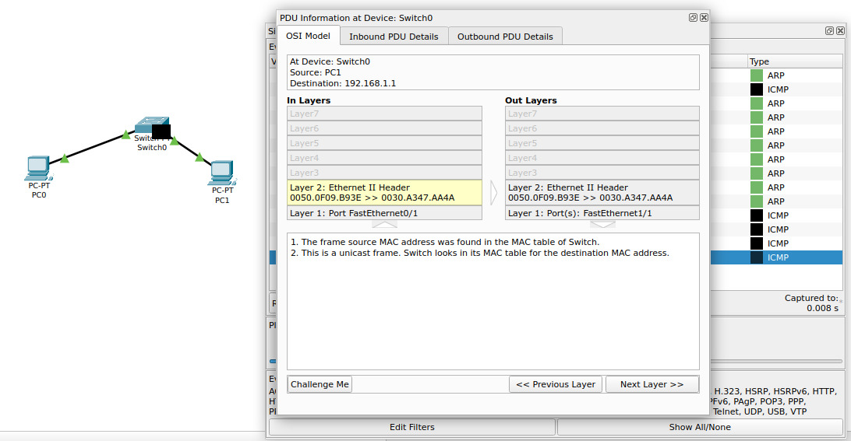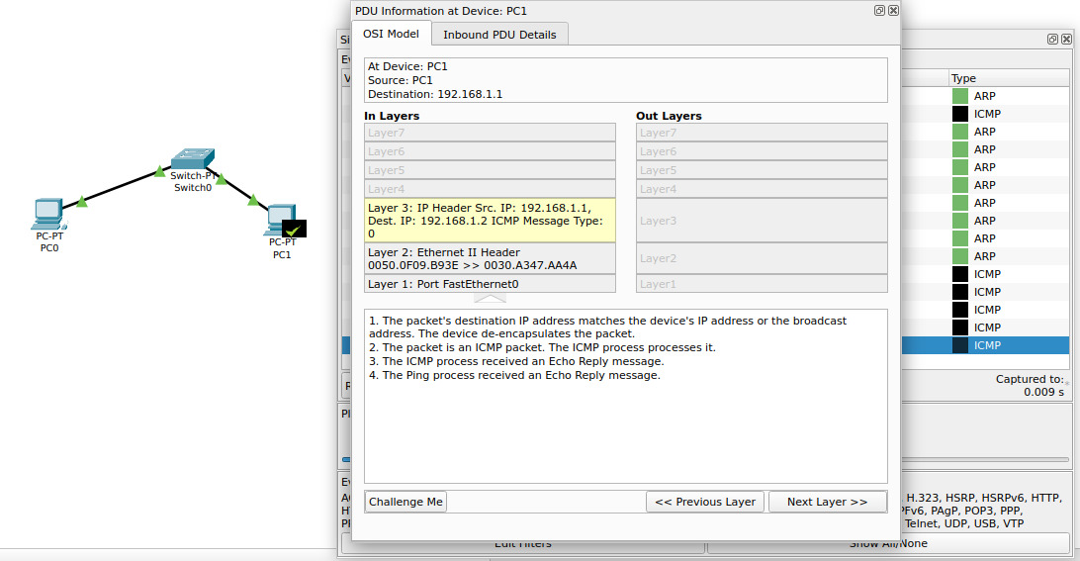

To ping the PC0 from PC1, the PC1 needs the MAC address of PC0; which is acquired by the ARP request (observed to be a broadcast). After the ARP reply comes from the PC0, PC1 will know the MAC address of PC0 and send the ICMP echo request to the destination MAC of PC0(unicast). PC0 will send a ICMP Echo reply to the PC1 upon receiving the ICMP Echo request.

## **CABLES:**

### CONSOLE CABLE:

A console cable, often called a "rollover cable" or "Cisco console cable," is used to connect a computer or terminal to the console port of a networking device, such as a router, switch, or firewall. This connection allows direct access to the device's command-line interface (CLI) for configuration, monitoring, and troubleshooting purposes.

### COPPER STRAIGHT THROUGH CABLE:

A copper straight cable, commonly referred to as a straight-through Ethernet cable, is used to connect different types of devices in a network, such as a computer to a switch, a router to a modem, or a switch to a router. It is the most common type of Ethernet cable used in local area networks (LANs).

**Usage**:

* **PC to Switch/Hub**: Connecting a computer to a network switch or hub.
* **Router to Modem**: Connecting a router to a broadband modem.
* **PC to Router**: Directly connecting a computer to a router.
* **Switch to Router**: Connecting a network switch to a router.

### COPPER CROSSOVER CABLE:

A copper crossover cable is a type of Ethernet cable used to connect similar devices directly to each other without the need for a network switch or router. The wiring of the cable is designed to "cross over" the transmit and receive signals, allowing two devices to communicate directly.

**PC to PC:** Connecting two computers directly without a switch or hub.

**Switch to Switch:** Connecting two network switches directly without using a router or another intermediate device.

**Router to Router:** Connecting two routers directly for certain networking setups.

**PC to Router:** In older setups, sometimes used to connect a computer directly to a router for configuration or testing purposes.

### FIBER OPTIC CABLES:

Fiber optic cables are used to transmit data as pulses of light through thin strands of glass or plastic fibers. They are a key component in modern telecommunications and networking, offering high-speed data transfer, long-distance communication, and resistance to electromagnetic interference.

### PHONE CABLES:

Phone cables, also known as telephone or landline cables, are used to connect telephones to the public switched telephone network (PSTN) or a private branch exchange (PBX) system. They carry voice signals (and sometimes data) over relatively short distances, typically within homes, offices, or other buildings.

### COAXIAL CABLES:

Coaxial cables, commonly known as coax cables, are used to transmit high-frequency signals, particularly for television, internet, and radio communications. They consist of a central conductor, an insulating layer, a metallic shield, and an outer insulating layer, all arranged coaxially, meaning they share the same axis.

### SERIAL DCE:

Serial DCE (Data Circuit-terminating Equipment) cables are used to connect Data Terminal Equipment (DTE), such as a computer or router, to Data Circuit-terminating Equipment (DCE), such as a modem or a network switch. The DCE cable is responsible for establishing and maintaining the data connection, typically in serial communication.

### SERIAL DTE:

Serial DTE (Data Terminal Equipment) refers to a device that communicates with a Data Circuit-terminating Equipment (DCE) in a serial communication setup. The role of a DTE device is to generate, process, or consume data, while the DCE device typically provides the connection to a network or communication line.

### OCTAL CABLE:

An octal cable, also known as an octopus cable or a serial breakout cable, is used in networking and telecommunications environments to connect multiple serial devices to a single serial interface on a server, router, or terminal server. The cable typically has a single connector on one end that connects to the serial interface and breaks out into eight individual serial connectors on the other end.

### IOT CUSTOM CABLE:

**IoT (Internet of Things) custom cables** are specialized cables designed to connect various IoT devices to each other or to a central system for data transmission and power supply. These cables are tailored to meet the specific needs of IoT applications, which often involve diverse types of sensors, actuators, and communication modules.

### USB CABLES:

USB (Universal Serial Bus) cables are a type of data and power cable used to connect various devices to computers and other electronic devices. They are one of the most common types of cables used for connecting peripherals and transferring data